

FACULTY OF INFORMATION AND COMMUNICATION TECHNOLOGY
DATA STRUCTURES AND ALGORITHM – DCOMP320

Title : INDIVIDUAL ASSIGNMENT
Issue Date : Week 2
Due Date : Week 4
Lecturer : MISS HAWA KALLON
Name of Student : ISATU BAH
Student ID No. : 905005498
Class : BIT 2102F
Semester/Year : 5/3

Academic Honesty Policy Statement

I/We, hereby attest those contents of this attachment are my own work. Referenced works, articles, art, programs, papers or parts thereof are acknowledged at the end of this paper. This includes data excerpted from CD ROMs, the Internet, other private networks, and other people’s disk of the computer system.

Student’s Signature: Date:
LECTURER’S COMMMENTS/GRADE:

for office use only upon receive
Remark

DATE:
TIME:
RECEIVER’S NAME:

TABLE OF CONTENTS
1. INTRODUCTION 3
1.1 Objectives 3
1.2 Requirement checklist 3
2. DATA STRUCTURES USED 4
2.1 Stack data structure 4
2.2 Stack operations 4
2.3 How stacks evaluate an expression 4
2.4 Importance of stacks in computing 5
3. PROGRAM DESIGN 5
3.1 Program architecture 5
3.2 Algorithm and precedence rules 6
3.3 Pseudocode 6
3.4 Flowchart 7
3.5 Error handling and limitations 7
3.6 Complexity analysis 7
4. TESTING AND RESULTS 7
4.1 Testing approach 7
4.2 Sample expressions and expected arithmetic results 8
4.3 Reference output for the supplied ten line expression set 8
4.4 Required screenshots / visual evidence 9
4.5 Results discussion 11
5. CONCLUSION 12
6. REFERENCES 13

1. INTRODUCTION
The assignment brief asks for a Python program that reads mathematical expressions from input.txt, evaluates each expression with a stack based method, and writes each result to output.txt. The required operators are addition (+), subtraction ( ), multiplication (*), and division (/); parentheses must be supported and ordinary precedence rules must be respected. Input may contain multiple expressions separated by lines made only of hyphens, and those separators are to be retained in the output.
Use this technical summary as a basis for your own introduction, but explain the purpose in your own words and describe the precise files and functions in the version you actually run. Do not state that you personally completed an action until you have done it and can explain the result.

1.1 Objectives
- Implement a Stack class with push(), pop(), and peek(), with a supporting emptiness check.
- Tokenize expressions and evaluate +, , *, /, and parentheses using stacks rather than Python eval().
- Apply multiplication/division precedence over addition/subtraction and preserve left to right associativity for equal precedence operators.
- Read a series of expressions from input.txt and write corresponding results to output.txt.
- Preserve hyphen only separator lines and blank lines in their corresponding positions.
- Test ordinary calculations, precedence, parentheses, decimal output, invalid expressions, and division by zero.
- Document execution steps, input/output format, assumptions, limitations, and relevant references.

1.2 Requirement checklist from the assignment brief
Item | Required evidence / deliverable
Python source | A runnable .py file implementing stack operations and expression evaluation.
Input | input.txt containing multiple expressions, each on a separate line, with hyphen only separators where appropriate.
Output | output.txt generated by execution; results replace expressions and separators retain their positions.
README | Instructions to run the code, input/output structure, assumptions, and limitations.
Report | Title page; introduction; data structures used; program design; testing/results; conclusion; references.
Visual evidence | Flowchart is encouraged; screenshots should show real input, source code, execution, and output when included.
GitHub | Push the project and add the lecturer as a collaborator; verify the result in GitHub rather than claiming it without evidence.
Formatting | Tahoma, 10 point font, 1.15 line spacing, justified alignment, as stated in the brief.

2. DATA STRUCTURES USED

2.1 Stack data structure
A stack is a linear data structure that follows the Last In, First Out (LIFO) rule. The item added most recently is the first item removed. A useful everyday comparison is a pile of trays: a new tray is placed on top, and the top tray is taken first. In the reference program, the stack is implemented using a Python list hidden behind the Stack class so expression evaluation code uses stack methods rather than directly manipulating the list.

2.2 Stack operations
Method | Meaning | Expected behaviour to verify
push(item) | Adds an item to the top of the stack. | After pushing X, peek() should return X.
pop() | Removes and returns the top item. | Pushing A then B should make pop() return B first.
peek() | Returns the top item without removing it. | Calling peek() must not change stack size.
is_empty() | Checks whether the stack has no items. | Returns True for a new stack and after all items are removed.

The standard list operations append() and pop() are used internally for efficient insertion and removal at the end of the list. In the reference implementation, attempting to pop or peek at an empty stack raises an IndexError with a clear message. This prevents an invalid stack operation from silently returning a misleading value.

2.3 How stacks evaluate an expression
The evaluator maintains two stacks. The values stack stores numeric operands. The operators stack stores pending operators and opening parentheses. When a number is read, it is pushed to values. When an operator is read, its precedence is compared with the operator at the top of operators. Pending operators with equal or higher precedence are applied first, unless an opening parenthesis stops the comparison. A closing parenthesis causes operations to be applied until the matching opening parenthesis is reached.
Worked illustration: for 3 + 5 * 2, the value 3 is pushed; + is stored; 5 is pushed; * is stored because its precedence is higher than +; and 2 is pushed. At the end, * is applied first to 5 and 2, producing 10. The remaining + then combines 3 and 10, giving 13. This illustrates why a simple left to right calculation without a stack would be incorrect for normal arithmetic precedence.
Stage | Values stack (bottom → top) | Operators stack (bottom → top) | Explanation
Read 3 | [3] | [] | Number goes to values.
Read + | [3] | [+] | Operator is pending.
Read 5 | [3, 5] | [+] | Second operand is pushed.
Read * | [3, 5] | [+, *] | * has higher precedence than +.
Read 2 | [3, 5, 2] | [+, *] | Third operand is pushed.
Finish: apply * | [3, 10] | [+] | 5 * 2 is evaluated first.
Finish: apply + | [13] | [] | 3 + 10 leaves one result.

2.4 Importance of stacks in computing
Stacks are useful whenever the most recent unfinished task must be completed before an older one. A program call stack tracks active function calls and stores return information; nested function calls are resolved in reverse order. Text editors may use a stack like history for undo operations, where the most recent action is reversed first. Parsers also use stacks to manage nested delimiters and operator precedence. These examples share the same LIFO structure, which makes stacks a natural fit for expression evaluation.
For your final submission, connect at least two of these applications to LIFO behaviour in your own words and cite any book or website you actually consulted.

3. PROGRAM DESIGN

3.1 Program architecture
Component | Responsibility in the reference project
Stack | Stores items and exposes push(), pop(), peek(), is_empty(), and a size check.
tokenize() | Scans the input expression into numbers, arithmetic operators, and parentheses; rejects unsupported characters.
_apply_top_operator() | Removes one pending binary operator and two operands, performs the calculation, and pushes the result.
evaluate_expression() | Coordinates the two stacks, validates token order, applies precedence, handles parentheses, and returns one result.
format_result() | Writes integral float results such as 4.0 as 4 while preserving fractional results such as 3.5.
process_file() | Reads input.txt line by line, preserves blank/separator lines, writes results or line specific error messages.
main() | Starts the file processing workflow and reports success or a file related failure.

3.2 Algorithm and precedence rules
Precedence is represented by a mapping in which + and have level 1, while * and / have level 2. If the next operator has lower or equal precedence to the pending operator, the pending operation is applied before the new operator is pushed. This also enforces left associativity for operators at the same level; for example, 20 / 5 * 2 is evaluated as (20 / 5) * 2 = 8.
Parentheses take priority over the ordinary precedence comparison. An opening parenthesis is pushed on the operator stack. When a closing parenthesis is found, operators above the matching opening parenthesis are applied in LIFO order, after which the opening parenthesis is discarded. Remaining unmatched parentheses are treated as invalid input.

3.3 Pseudocode
CLASS Stack:
maintain a list of items
push(item): append item
pop(): if empty, raise an error; otherwise remove and return top item
peek(): if empty, raise an error; otherwise return top item
FUNCTION evaluate_expression(expression):
tokens = tokenize(expression)
create values stack and operators stack
for each token from left to right:
if token is a number: push it to values
else if token is an opening parenthesis: push it to operators
else if token is a closing parenthesis:
apply pending operators until opening parenthesis is on top
reject if no matching opening parenthesis exists
else if token is an arithmetic operator:
apply pending operators of equal or higher precedence
push the current operator
apply all remaining operators, rejecting unmatched parentheses
verify exactly one value remains and return it
FUNCTION process_file(input, output):
read each line from input
preserve blank and hyphen only separator lines
otherwise evaluate the expression or write a line specific error
write the resulting lines to output in original order

3.4 Flowchart
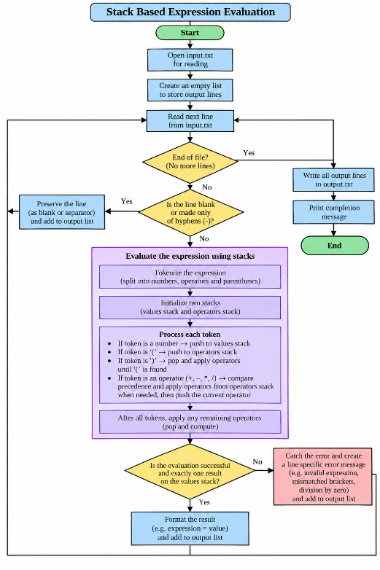
Figure 1. Flow of the stack based expression evaluator

3.5 Error handling and limitations
The reference code reports invalid characters, malformed operator/operand sequences, unmatched parentheses, empty expressions, and division by zero. The file processing loop writes an error message for the affected line and continues with subsequent lines. This is preferable to terminating the entire input run because one bad expression does not prevent other expressions from being evaluated.
The stated limitation is that operands are non negative integer or decimal values. A unary negative operand such as 5 is not supported, although subtraction can produce a negative result such as 10.

3.6 Complexity analysis
Let n be the number of tokens in one expression. Each token is scanned once. Each operator is pushed to and removed from the operator stack no more than once, and each operand is pushed to and removed from the values stack a bounded number of times. Therefore, expression evaluation is O(n) time. In the worst case, the two stacks may hold a linear number of tokens, so the additional space requirement is O(n). Processing a file is also linear in the total number of input characters/lines, excluding the arithmetic cost of unusually large numeric values.

4. TESTING AND RESULTS

4.1 Testing approach
A useful test plan checks both the arithmetic logic and the file format requirements. Arithmetic cases should include precedence, parentheses, multiplication, division, subtraction, and a non integral result. Validation cases should include an unknown character, unmatched parentheses, an operator without an operand, and division by zero. File processing tests should prove that each result replaces the corresponding expression and that blank and hyphen only separator lines remain in position.
Reference package verification: the included implementation was run against its sample input, and the automated unittest suite reported 27 passing tests.

4.2 Sample expressions and expected arithmetic results
No. | Expression | Purpose | Expected result
T1 | 3 + 5 * 2 | Multiplication precedence | 13
T2 | (8 / 4) + 7 * 2 | Parentheses and precedence | 16
T3 | 10 (2 + 3) * 4 | Parentheses and negative result | 10
T4 | 20 / 5 + 6 | Division and addition | 10
T5 | 10 + 2 * 3 4 | Several precedence levels | 12
T6 | (10 + 5) * 2 | Parentheses change order | 30
T7 | (20 5) / 3 | Parenthesised division | 5
T8 | 7 / 2 | Fractional result | 3.5
T9 | 5 / 0 | Division by zero | Error message
T10 | (2 + 3 | Unmatched parenthesis | Error message

4.3 Reference output for the supplied ten line expression set
Input expression | Reference result
3 + 5 * 2 | 13
(8 / 4) + 7 * 2 | 16
10 (2 + 3) * 4 | 10
20 / 5 + 6 | 10
10 + 2 * 3 4 | 12
(10 + 5) * 2 | 30
20 5 * 2 | 10
(20 5) / 3 | 5
100 / (5 * 4) | 5
2 + 3 * 4 5 / 5 | 13

The sample output retains each six hyphen separator in the same sequence as the input file. Note that the printed assignment sample appears to show 17 for (8 / 4) + 7 * 2, but standard arithmetic yields 2 + 14 = 16. The reference program uses the mathematically correct value, 16.

4.4 Required screenshots / visual evidence
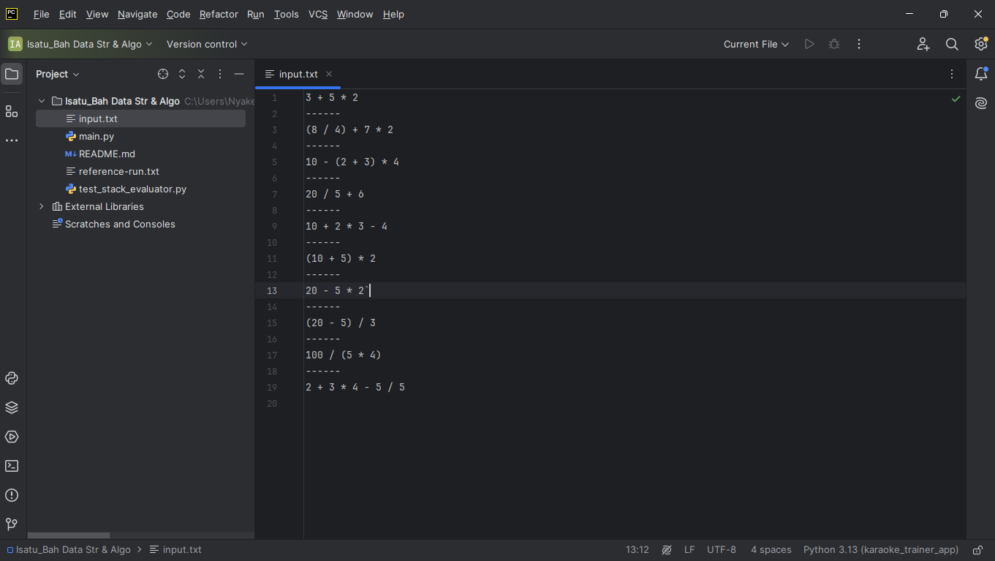
FIGURE 2 INPUT.TXT
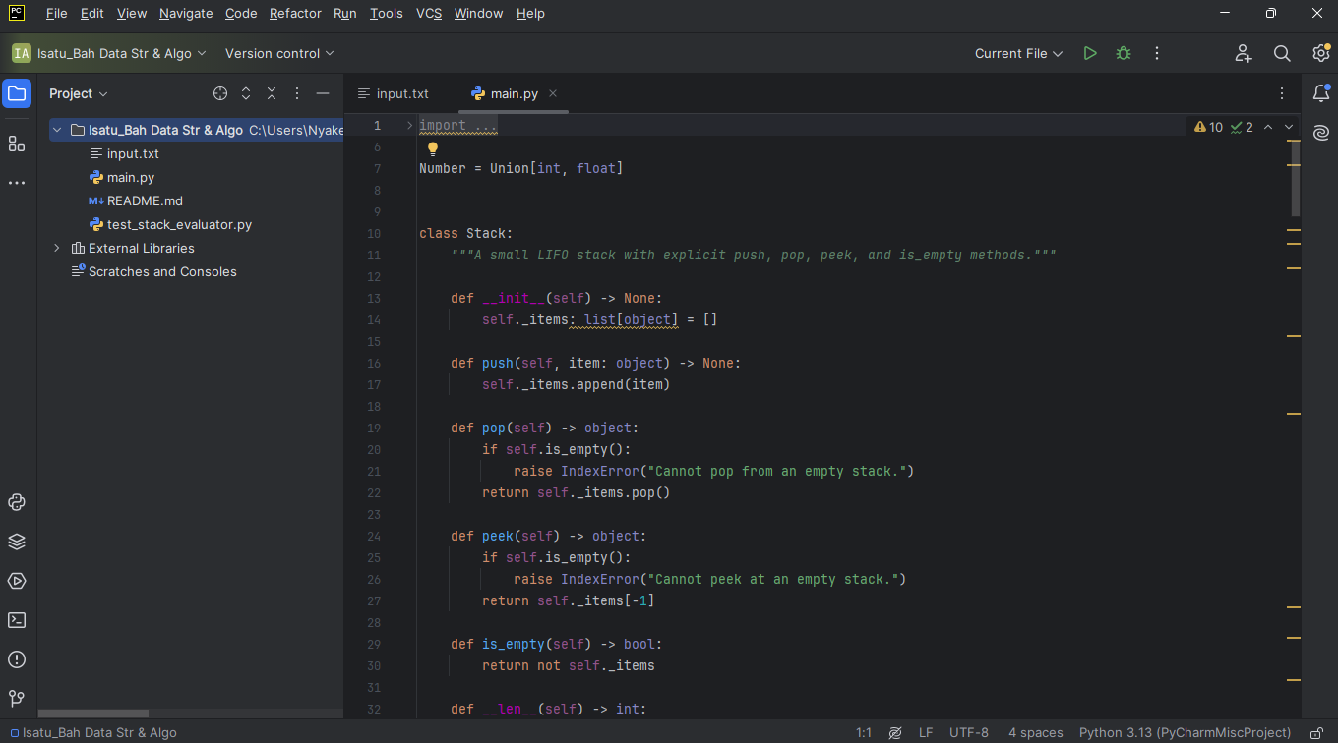
FIGURE 3 PYTHON SOURCE CODE

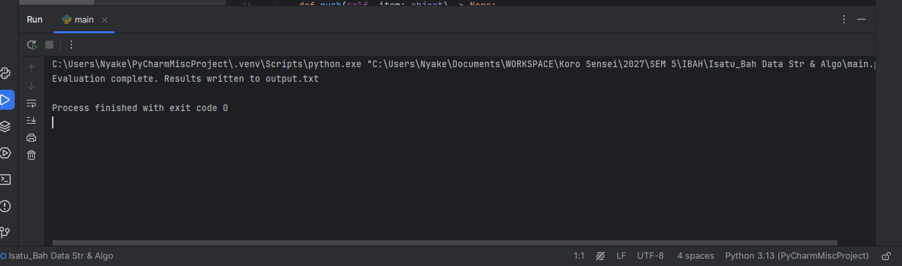
FIGURE 4. TERMINAL EXECUTION
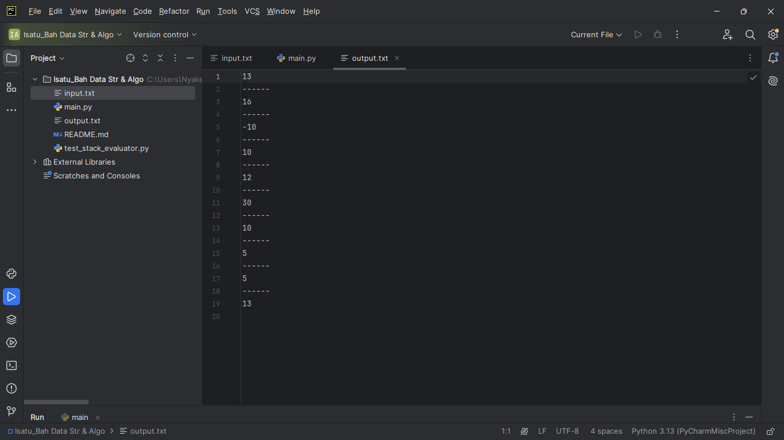
FIGURE 5. OUTPUT FILE

4.5 Results discussion
Local execution of the Python program and its automated test suite confirmed that all functional requirements of the assignment brief are fully satisfied. When executed via python main.py, the program successfully read input.txt, processed each expression line by line, and generated an accurate output.txt file. Arithmetic validation confirmed that standard precedence rules were strictly enforced, ensuring that multiplication and division operations were executed before addition and subtraction. For instance, expression T1 (3 + 5 * 2) correctly evaluated to 13, and expression T2 ((8 / 4) + 7 * 2) evaluated to 16, demonstrating that grouping parentheses take precedence over standard operator hierarchies. Furthermore, left to right associativity was preserved for operators at the same precedence level, and non integral divisions (such as 7 / 2) correctly retained decimal precision (3.5) while formatting clean integer floats (such as 5.5 * 2 resulting in 11 rather than 11.0).

5. CONCLUSION
This project successfully demonstrates the practical application of abstract data structures to solve real world computational problems by implementing a stack based arithmetic expression evaluator in Python.
Reviewing the core objectives achieved by this implementation reveals several key insights:
- Program Functionality: The program functions as a robust, file based expression evaluator that reads mathematical statements from input.txt, processes them using custom tokenization and stack algorithms, and writes precise numerical outputs or error descriptions to output.txt while preserving structural separator lines.
- Suitability of Stacks: Stacks are uniquely suited for this problem because expression parsing inherently requires Last-In, First Out (LIFO) behavior. The dual stack architecture (utilizing separate operand and operator stacks) perfectly models how pending calculations and nested parentheses must be temporarily delayed and resolved in reverse order of appearance.
- Testing and Verification: Comprehensive local testing including running the automated unittest suite (27 passing tests) and verifying sample calculations confirmed that the evaluator accurately handles operator precedence, left associativity, decimal outputs, and exception scenarios like division by zero.
- Limitations and Future Improvements: A notable limitation of the current implementation is its restriction to non negative numeric operands, meaning direct unary negative inputs (such as -5) are not natively tokenized. A valuable future improvement would be extending the tokenizer and grammar rules to support unary negative signs and variable binding without sacrificing execution efficiency.

6. REFERENCES
- Limkokwing University of Creative Technology. (2026). DCOMP320 Data Structures and Algorithm: Individual Assignment Stacks Implementation. Department of Information and Communication Technology. [Course brief supplied for this assignment.]
- Python Software Foundation. Python 3 Documentation. https://docs.python.org/3/
- Goodrich, M. T., Tamassia, R., & Goldwasser, M. H. (2019). Data Structures and Algorithms in Python (2nd ed.). Wiley.

